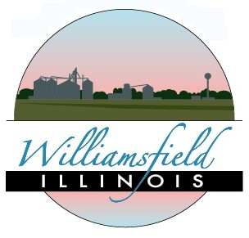
WILLIAMSFIELD AREA DEVELOPMENT
PO Box 420, Williamsfield, Illinois 61489 www.williamsfield.org/

Dear Williamsfield Supporter:

The Williamsfield Area Development Board invites you to join us as member and supporter of WADCO in 2019. WADCO (Williamsfield Area Development Corporation) is a registered non-profit organization of local business people, organization leaders, and passionate residents devoted to the sustainability and betterment of Williamsfield and all the entities within it.
Williamsfield Area Development was established in 1991 and was initially used as an advertising agent and financial entity (hence, the “corporation”) for construction of the, now, 3 Williamsfield housing subdivisions and the American Legion. But since then, WADCO has developed into an organization responsible for additional fund-raising, advertising, business sustainability, beautification, etc. alongside and in partnership with the Village Board of Trustees. WADCO has:
-sponsored and hosted previous WIU Community “Mapping” programs (although the last one was
sponsored & hosted by the Village Board directly)
-held community open-forums and focus groups
-developed the http://www.williamsfield.org website (now managed by an independent Wadco member)
-funded newspaper and billboard advertisements in nearby cities
-provided Welcome Baskets to new residents (and businesses)
-helped local businesses and organizations advertise themselves and their events
-overseen the construction of “Welcome to Williamsfield” signs, downtown banners, and the planting of over 100 flowering trees along Williamsfield streets, & new “wayfinding signs” soon-to-be installed.
But we continue to need the help and support of Williamsfield Supporters, like you. Even if you don’t have the time to actively participate in WADCO’s quarterly meetings or special evens, your tax-deductible membership or gift will help to WADCO to continually provide improvements and advertisements to our great community.
Additionally, businesses who join have access to a free advertisement, provided by WADCO, in the Weekly Post newspaper out of Elmwood.

Membership dues are $10 annually for individuals & $100 for business members (annual memberships begin in April each year). We hope you will continue to find value in such an organization and its efforts, and ask that you return the form below with your dues payable to WADCO. Thank you again; we appreciate your membership and your support! Sincerely,

Andrew Fritz, President
Williamsfield Area Development Corporation
-------------------------------------------------------------------------------------------------------------------------------
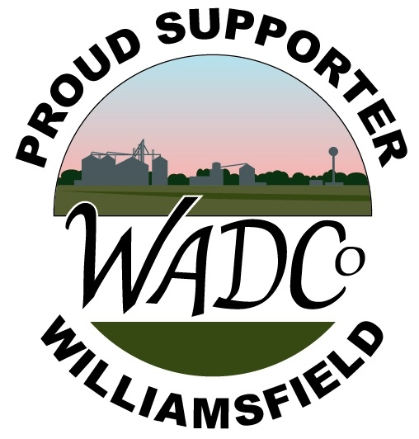
MEMBERSHIP APPLICATION

Member’s Name: ____________________________________________________
] Address: ___________________________________________________________
___________________________________________________________
Phone: ___________________________Include you in our email updates?_______
Email: ____________________________________________________________
(please make checks payable to WADCO; $10/individual or $100/business membership)
Return this application & dues to: Williamsfield Area Development, PO Box 278, Williamsfield, IL 61489

